FULL PAPER TEMPLATE for INTERNATIONAL CONFERENCE ON E-LEARNING (ICOEL 2019)

First A. Author*¹, Second B. Author² and Third C. Author³

¹Authors’ Department, Institute, City, COUNTRY.
(E-mail: firstauthorsname@aaaa.bbb)
² Author’s Department, Institute, City, COUNTRY.
(E-mail: Secondauthorsname@aaaa.bbb)
*corresponding author
² Author’s Department, Institute, City, COUNTRY.
(E-mail: Thirdauthorsname@aaaa.bbb)

ABSTRACT
All manuscripts should be accompanied by an abstract, of not more than 300 words each, written in English. The abstract should not only indicate the subject and scope of the paper but also summarize the author’s conclusion. Structured abstract must be a brief, comprehensive summary of the contents of the article. It allows readers to survey the contents of an article quickly. This abstract summarizes the major aspects of a paper. It should succinctly summarize the purpose of the paper, the methods used, the major results, and conclusions.

Keywords: Keyword 1, Keyword 2, Keyword 3 (Min 3 key words & Max 5 Key words)

INTRODUCTION
This template explains and demonstrates how to prepare your ICOEL2019 final manuscript. The best is to read these instructions and follow the outline of this text. Please make the page settings of your word processor to A4 format (21 x 29.7 cm or 8 x 11 inches); with the margins: bottom 1.5 cm (0.59 in) and top 2.5 cm (0.98 in), right/left margins must be 2 cm (0.78 in).
This format is to be used for submissions of full papers in ICOEL. We therefore ask that authors follow some simple guidelines. In essence, you should format your paper exactly like this document. The easiest way to do this is simply to download a template from the conference web site, and replace the content with your own material.
The full paper should be written in MS Word format, preferably as .doc file. Use single-spaces in 12 point Times New Roman. Please indent the text paragraphs. Please state clearly the aim (and scope) of the study, the materials and methods, and the main findings and brief analysis of the study. Please observe Figure 1 and Table 1 to include figures and tables in the abstract, respectively.
Authors are requested to submit the full paper (6 to 8 pages in length) in electronic form (MS-Word) our online submission page.

MAIN RESULTS
The section headings are in boldface capital and uppercase letters.

Sections Headings
Second level headings are typed in boldface with capital first letters (like the subsection heading of this paragraph). Figures can be included in your paper and referred to in the text as Figure 1, Figure 2, and so on.
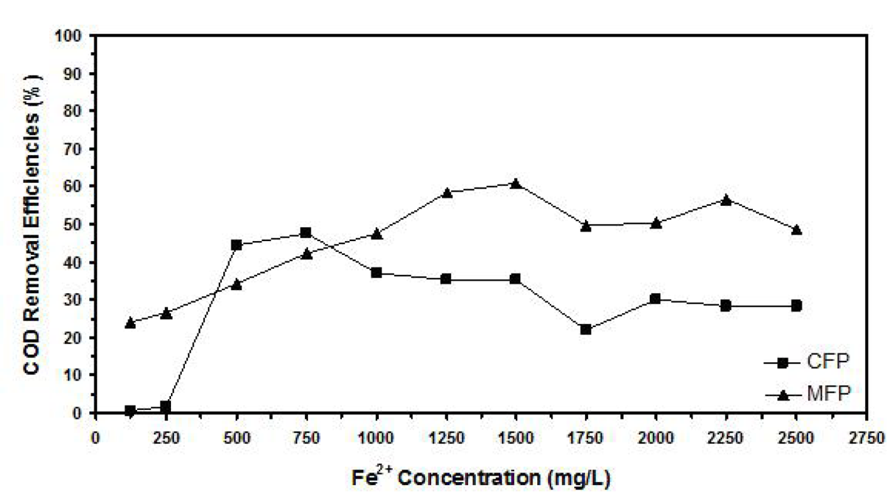
Figure 1. Example of figure for the full paper.

A table should be inserted like the one below and referred in the text as Table 1, Table 2, and so on.

Table 1. Example of table for the full paper
Contents of Table
(1)
CONCLUSION
The conclusion is intended to help the reader understand why your research should matter to them after they have finished reading the paper. A conclusion is not merely a summary of the main topics covered or a re-statement of your research problem but a synthesis of key points and, if applicable, where you recommend new areas for future research.

ACKNOWLEDGEMENT
The authors can add in the acknowledgement if they would like to express their appreciation for the support of the sponsors with certain Project No, individual or organization/institution.

REFERENCES
- Abu, A.B. and Zakaria, B. Title of the manuscript in journal. Name of the Journal Volume (Year), Page no.
- Klemmer, R.S., Thomsen, M., Phelps-Goodman, E., Lee, R. and Landay, J.A. Title of the article in proceedings. In Title of the Proceedings, Publisher (Year), Page no.
- Schwartz, M. Title of the Book. (Publisher Name, Publisher City, Year), Page no.
- Choo, S.M. Title of a PhD thesis. Institution, Ph.D. Thesis, Year.

